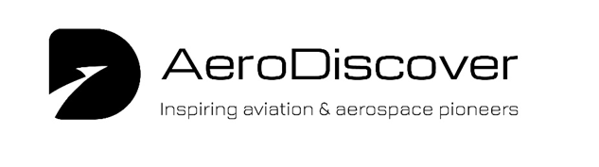

**Good to Know**

**Pilot Fact Sheet**

**Why More Pilots Are Needed**:

The aviation industry is buzzing with opportunity, and right now, there’s a big need for new pilots! With more people flying and many experienced pilots retiring, airlines around the world are on the lookout for fresh talent.

**Here’s what you need to know:**

* **High Demand:** The industry will need over 600,000 new pilots by 2040 to keep up with passenger and cargo flights.
* **Training Opportunities:** Flight schools are busier than ever, but they still can’t quite meet the demand for trained pilots.
* **Career Perks:** Because pilots are so in demand, new recruits enjoy excellent job stability, strong starting salaries, and other great perks.

If you’re considering a career in aviation, now’s a fantastic time to get started and take advantage of these exciting opportunities!

Whu

**Qualifications and Training Pathway**

1. **Basic Requirements**:
   * **Age**: Minimum of 18 years old.
   * **Height**: Typically, at least 5ft 2in.
   * **Education**: Five GCSEs, including Maths, English, and Science.
2. **Medical Requirements**:
   * **Class 1 Medical Certificate**: Candidates must pass a physical and mental fitness test to meet aviation health standards.
3. **Flight Training**:
   * **Airline Transport Pilot Licence (ATPL)**: Requires training through an accredited flight school. Trainees usually start with a "frozen" ATPL, which remains inactive until they accrue 1,500 hours of flying experience as a co-pilot or first officer.
   * **Training Schemes**: Many UK airlines partner with flight schools to offer sponsored training programmes, which can provide a conditional job offer post-training.
   * **Training Duration**: The integrated course takes approximately 18 months, covering both theoretical and practical aspects, including foundational flight training and time in flight simulators.
   * **Combined Degrees & Flight Training:** Some UK Universities offer a degree linked to aviation with pilot training, which can be a good insurance call by offering other employment opportunities if a person loses their Class 1 medical certificate, or if the airline industry experiences a downturn.
4. **Costs**:
   * Full-time courses range between £100,000 and £125,000.
   * Part-time modular courses can be less expensive, though they require prior flying experience (such as a private pilot’s licence) and tend to be a pay-as-you-go option.
5. **Skills and Attributes**:
   * **Communication and Teamwork**: Pilots work in close quarters, often for long hours, and must maintain effective communication.
   * **Resilience and Adaptability**: The aviation industry is highly susceptible to external factors, such as economic downturns or health crises, which can impact job security.
   * **Self-assessment**: The ability to gauge one’s own wellbeing is increasingly emphasised in training, including regular psychometric evaluations and mental health awareness.

**Career Progression and Earnings**

* **First Officer/Co-Pilot**: Starting salaries vary but are typically around £45,000 to £60,000 with major airlines.
* **Captain**: Once experienced, pilots can move up to captain roles, with salaries reaching £130,000 on short-haul flights and over £240,000 on long-haul flights.

**Lifestyle and Challenges**

* **Shift Patterns**: Schedules often include early or late shifts, affecting personal routines and physical health.
* **Isolation and Stress**: Working long hours in the cockpit can be isolating. Pilots are allowed controlled rest periods on long-haul flights to mitigate fatigue.
* **Job Security**: Although pilot jobs are generally well-compensated, the industry is vulnerable to external factors like economic recessions and environmental pressures.