**KS4 WOODEN HELICOPTER**

SUBJECT: Aeronautics

TOPIC: Propulsion

DESCRIPTION: Make two pieces of wood into a simple helicopter.

**MATERIALS and TOOLS:**

1/4-inch dowel rod 7 1/2 inches long

1 piece of pine or other soft wood 3/4x8xl/4 inches

Carving knife or wood rasp

Electric drill and 1/4-inch drill bit

Fine sandpaper

Glue

Pencil

Ruler

**PROCEDURE:**

**Teachers – do your own risk assessment and make sure to always monitor your students for safe working practices.**

I. Carefully mark centre of the strip and drill a 1/4-inch hole.

2. Carefully carve or file the wood strip so that it becomes a propeller. Shape the blades into air foils. Remember to slant the air foils in the correct direction. Refer to the picture. Sand the blades smooth.

3. Push the dowel into the hole as shown in the figure. It may be necessary to glue the stick to keep it in the hole. When dry, the wooden helicopter is ready for test flights.

**FLYING THE WOODEN HELICOPTER:**

Hold the stick between the palms of your hands with the propeller upward. Rapidly move your palms in opposite directions. The movement will spin the stick and the propeller. Let go of the stick and watch its flight. If the stick moves immediately downward and strikes your knuckles, reverse the directions of your hands. During a good flight, the stick will climb straight up and settle gently, with the stick end down, to the floor. If the flight is poor, check the blades. They may be too thick or not cut at a good angle. Try reshaping both blades or shortening just one if the flight is erratic. The length of the stick can also be shortened to improve lift but if comes too short, it the wooden helicopter will become unstable.

**DISCUSSION:**

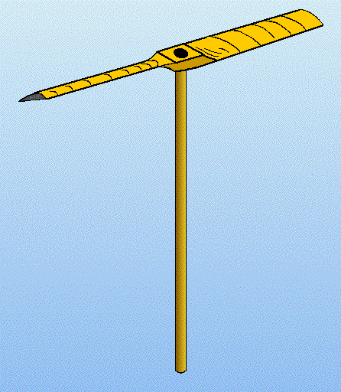The spinning motion of the wooden helicopter stabilises it in flight. Each blade acts like an airplane wing. As the blade moves through the air, the pressure below the blade is lowered, and the air pressure above the blade is lowered even more. The two pressures combine to provide lift so that the wooden helicopter can fly.