**KS3 "Maple Seed" Helicopters**

SUBJECT: Aeronautics

TOPIC: Helicopters

DESCRIPTION: Autorotating helicopters, based on the shape of maple seeds, are made from paper.

**MATERIALS:**

Paper -stiffer paper works better

Scissors

Paper clips

**PROCEDURE:**

1.Make copies of the maple seed pattern and derivatives on blank paper. Cut out each pattern.

2.Attach a paper clip to each design and slightly warp (curl) the paper to produce an air foil shape.

3.Drop each "maple seed" from a height of at least 5 feet and watch its fall.

4.If the design fails to autorotate, adjust the position of the paper clip slightly. Keep adjusting the clip until the "maple seed" begins autorotating as it falls.

5.Experiment with different designs of your own making.

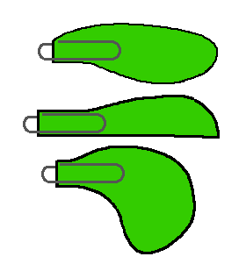

**DISCUSSION:**

Maple seeds are superb autorotating helicopters. They begin rotating almost from the moment they are released from the tree. Even seeds that are poorly shaped or have badly damaged blades (wings) rotate with "ease."

Autorotation takes place because of the asymmetrical nature of maple seeds (and of paper copies). The centre of mass of the seed is shifted well to one end while its centre of lift is approximately in the middle. In a complicated process, the forces at work as the seed falls combine to begin a circular rotation of the seed about its centre of mass. The rotation inscribes a cone around the axis of fall. The shape of the cone will vary depending upon the aerodynamic qualities of the seed's blade or wing. A blade with minimal lift properties will inscribe a steep-side cone while a blade with strong lift properties will inscribe a very flattened cone.